Output Documentation

nextbus.rb by Jena Pung

Error Checking:

Route too vague:



Route not found:

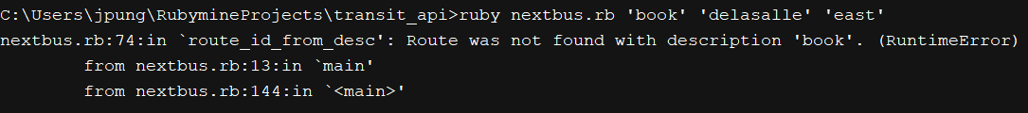

Stop too vague:



Stop not found:



Direction not found:



Invalid number of arguments:



Invalid direction argument given:



Successful output:

